**Implement Programs For Time Series Data Cleaning, Loading, And Handling Time Series Data And Pre-Processing Techniques**

**EX:No.1 DATE: 25/01/2**

**AIM:**

To clean, preprocess, and visualize stock data, focusing on trend analysis and handling missing values.

**ALGORITHM:**

1. Load the dataset
2. Read the NFLX.csv file using pandas.
3. Display dataset information
4. Show general information (column names, data types, and non-null counts).
5. Print the first few rows of the dataset.
6. Generate summary statistics
7. Compute statistical measures like mean, min, max, and standard deviation.
8. Check for missing values
9. Identify and count missing values in each column.
10. Process Date Column (if available)
11. Convert the Date column to datetime format.
12. Sort the dataset by date.

**CODE:**

import pandas as pd  
import matplotlib.pyplot as plt  
  
# Load the dataset  
file_path = "/mnt/data/NFLX.csv"  
df = pd.read_csv("C:\\Users\\HDC0422279\\Downloads\\NFLX.csv")  
  
# Display basic info and first few rows  
print("Dataset Info:")  
df.info()  
print("\nFirst 5 Rows:")  
print(df.head())  
  
# Summary statistics  
print("\nSummary Statistics:")  
print(df.describe())  
  
# Check for missing values  
print("\nMissing Values:")  
print(df.isnull().sum())  
  
# Plot closing price trend if 'Date' and 'Close' columns exist  
if 'Date' in df.columns and 'Close' in df.columns:  
 df['Date'] = pd.to_datetime(df['Date']) # Ensure Date column is in datetime format  
 df.sort_values('Date', inplace=True) # Sort by date  
   
 plt.figure(figsize=(12, 6))  
 plt.plot(df['Date'], df['Close'], label='Closing Price', color='blue')  
 plt.xlabel('Date')  
 plt.ylabel('Stock Price (USD)')  
 plt.title('NFLX Stock Closing Price Over Time')  
 plt.legend()  
 plt.grid()  
 plt.show()  
else:  
 print("\nColumns 'Date' and 'Close' not found in dataset.")

**OUTPUT:**

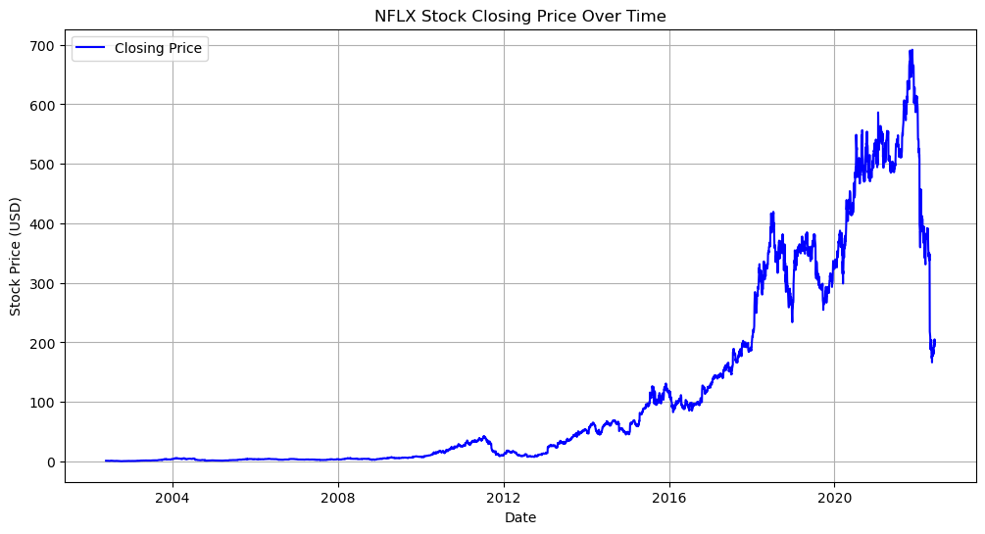

**RESULT:**

Thus the program has been completed and verified successfully.